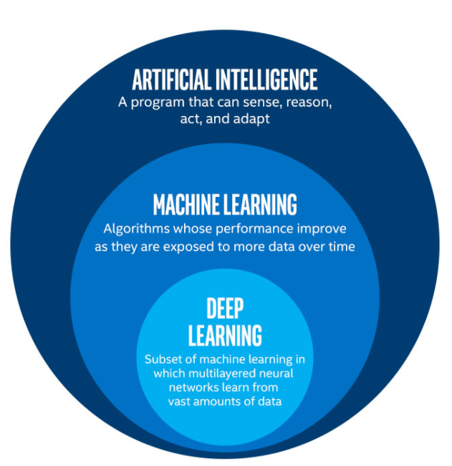**The difference between AI, Machine Learning, and Deep Learning**

Not a day goes by without a publication by every major news outlet on these topics but it seems the dividing lines between them still elude precise definition. The purpose of this article is to serve as an introduction to the field in layman terms.

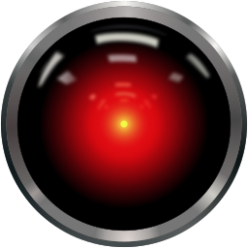 First, let us begin with **Artificial Intelligence** (**AI**): it is the demonstration of intelligent behavior by a machine. Although the philosophic debate of what constitutes intelligence is not resolved, we can reason by analogy. For example, most would agree that to become a great chess player you need to be intelligent, but machines have been beating human champions at the game for over 20 years. But Deep Blue[1] couldn’t tell if New York is a city or an ice-cream flavor. Hence we come to **Narrow AI** – machines (or “agents”) that act in a certain environment with clear goals, and often with the aid of predefined rules. On the contrary, **General AI** (**AGI**) would be a machine that is indistinguishable from a human.[2] What we see in fiction is usually General AI; some examples include HAL 9000 from the movie *2001: A Space Odyssey*, or Cortana from the game series HALO (later adopted by Microsoft for their Windows assistant). But what makes them different?

Algorithms, and here we start entering the field of **Machine Learning**, which is a subfield of AI. In a few words, the Machine Learning is about getting a machine, program, algorithm, or agent (here, all of these are used interchangeably) to “learn”, or “recognize patterns”, from data. How does this so-called learning occur depends on whom you ask? A few decades ago, the leading approach to the AI frontier were **Expert Systems**. These were a collection of hundreds or thousands of lines of code that encoded precise rules for the machine to follow depending on current conditions. You can think of it like this: ‘If it rains, take an umbrella’, ‘if it is sunny, take sunglasses’. The programmer would try to write as many rules as possible. It was thought, back then, that AGI will come about from defining rules about every possible situation.

But Deep Blue used an earlier form of Machine Learning, what computer scientists call searching algorithms. The main idea is that you define a set of basic rules, a set of possible actions, and let the computer search among those actions for which is the best, according to some criterion. What these machines do is calculate (all) possible moves and pick the one they think best. Modern Machine Learning is actually closer to **Statistical Learning**, and it employs statistics, mathematics, non-parametric methods (e.g. decision trees), and other field-dependent techniques (e.g. using *Grammars*, for **Natural Language Processing**) to model a problem using data and find the best solutions. Advances in computer hardware and data collection (see Big Data) made these methods extremely popular.

Enter **Neural Networks** (**NN**), a subfield of Machine Learning. Although their original inspiration was the brain, they are nothing more than complex mathematical functions. These 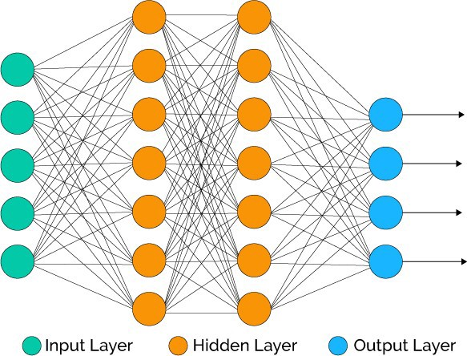work in much the same way as Machine Learning algorithms but demand a greater deal of computational power. They are called networks because all of their parts, or more precisely their “nodes”, are connected with each other. They are comprised of an Input Layer (for example, pixel values in an image), one or more hidden layers (some mathematical transformations that are ‘learned’ from the data), and an output layer (e.g. who is in the picture). The learning, just like with Statistical Learning, occurs by performing mathematic optimization (most commonly by using an algorithm called Gradient Descent[3]). Finally, we come to **Deep Learning** which is nothing else than using Neural Network with many hidden layers (some models may include a couple hundred such layers).

Closing, one could say that today’s AI is nothing more than glorified mathematics / statistics, and that we have a long way to go before achieving AGI, but I believe that is not the goal. The undeniable truth is that these techniques have interesting applications and have solved, and continue to solve, real problems, and we are still not harnessing their full potential.

Image sources:

http://digital-nebula.com/2018/01/03/top-terms-you-need-to-know-to-get-started-with-ai/ai-ml-dl-image/  
https://en.wikipedia.org/wiki/HAL_9000  
https://towardsdatascience.com/machine-learning-fundamentals-ii-neural-networks-f1e7b2cb3eef

1. The IBM computer that beat world chess champion Garry Kasparov in 1997.
2. The interested reader might want to take a look at the Turing test: <https://en.wikipedia.org/wiki/Turing_test>
3. https://en.wikipedia.org/wiki/Gradient_descent